**Section 1 - Meta information**

Team: Lasse, Sondre, Einar, Erik

Sprint number: 1

Schedule: 1 Week

Start time: 26.02.24

End time: 02.03.24

**Section 2 – Sprint planning note**

**2.1. Sprint goals**

The goal of this Sprint is to design the layout and aesthetics for the website pages, with general ideas of what should go on each of them. Specific ideas for content will be decided during the second Sprint.

**2.2. Definition of done**

All website pages are designed, and we have fully planned how the different pages fit together. All features are also fully planned. Plans are uploaded to the github repository.

**2.3. Sprint backlog items**

| **Item Id** | **Item description** | **Size Estimation** | **Customer Value** |
| --- | --- | --- | --- |
| U01 | As a developer I want to see the design of the homepage to code it. | 20 | High |
| U02 | As a developer, I want to know the layout of the floor plan page in order to create it according to the overall design of the website. | 13 | Low |
| U03 | As a developer I want to know the contact information of USN-start to create a contact information page. | 5 | Medium |
| U04 | As a developer I want to know which fonts and colors we are using in the website. | 10 | High |

**2.4. Kanban management board**

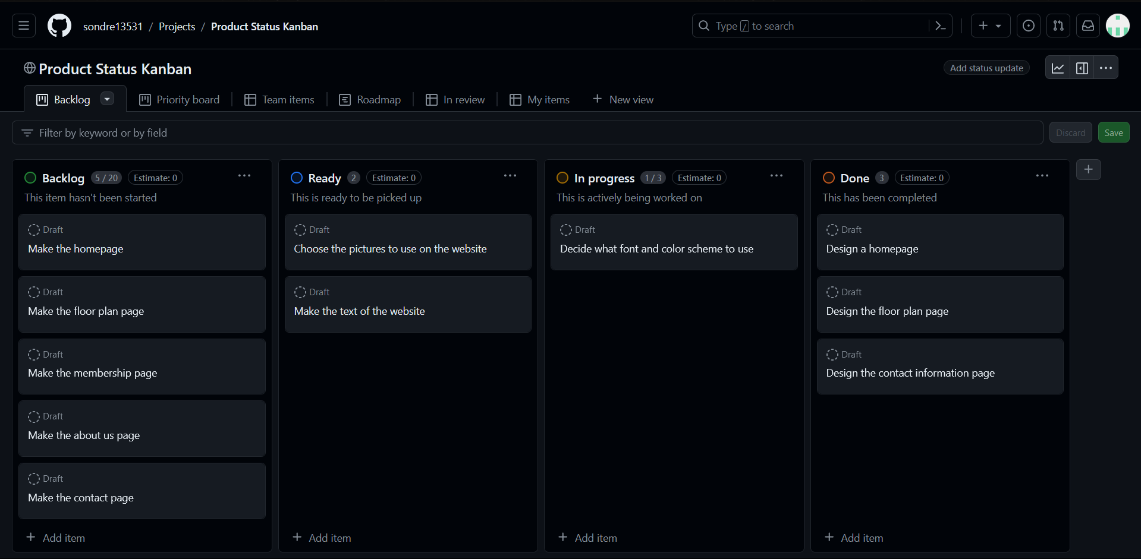

**Section 3 – Sprint Review note**

**3.1. Reflective summary**

The Scrum team shows what they accomplished during the sprint. Typically this takes the form of a demo of the new features.

Participants: Erik, Sondre, Lasse, Einar

Meeting duration, location: 1 hour, discord

Summary: Design choices, what got done vs what still needs to happen

Demonstration result: In-depth layout of each page, along with the membership prices, made in Figma

| Item id | Item Description | Estimation | Status | Demo |
| --- | --- | --- | --- | --- |
| U01 | As a developer I want to see the design of the homepage to code it. | 20 | Finished | Yes |
| U02 | As a developer, I want to know the layout of the floor plan page in order to create it according to the overall design of the website. | 13 | Finished | Yes |
| U03 | As a developer I want to know the contact information of USN-start to create a contact information page. | 5 | Finished | Yes |
| U04 | As a developer I want to know which fonts and colors we are using in the website. | 10 | In progress | No |

**Section 4 - Retrospective meeting note**

Participants: Lasse, Sondre, Einar, Erik

Meeting duration: 10 minutes

Location: Discord

Summary of :

* Start working more effective when we are working together, less time spent on discussing off-topic tasks or slowing down
* Find a solution on how to find common ground if there are disputes on how we design the website
* Be more realistic with what we’re implementing in our website
* Use more AI in our design to get new creative ideas if we find ourselves in a dead end creatively
* Continue having good communication with every group member and making sure everyone's voices is heard